| **Test Name** | | Delete a User | | | |
| --- | --- | --- | --- | --- | --- |
| **Use Case Tested:** | | Use Case – Delete a User | | | |
| **Test Description:** | | User finds a record entered for a User  User navigates to Search tab and selects Users, or selects Search Users button from welcome page  User is presented with a list of users  User can delete any user except the currently logged in user | | | |
| **Pre-conditions** | | User must login as an administrator  User records must exist | | | |
| **Post-conditions** | | User has been deleted | | | |
| **Notes:** | |  | | | |
| **Result (Pass/Fail/Warning/Incomplete)** | |  | | | |
|  | **TEST STEP** | | **EXPECTED TEST RESULTS** | P | F |
|  | User selects “Search > Search Users” from the menu bar or selects Search Medication Types button on Admin Home page | | A list of user records is returned – using tab  A list of user records is returned – using button | X  X |  |
|  | User clicks the Delete user button on a desired user | | A confirmation prompt pops up | X |  |
|  | User confirms the deletion | | The user is deleted and no longer appears in the list. | X |  |

|  |  |  |  |  |  |
| --- | --- | --- | --- | --- | --- |
| **Test Data Table** | | | | | |
|  | **1** | **2** | **3** | **4** | **5** |
| Test – 1 | Username = frank |  |  |  |  |
| Test – |  |  |  |  |  |
| Test – |  |  |  |  |  |

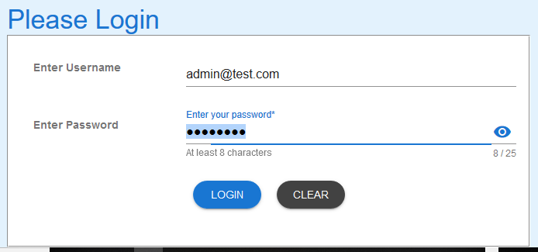

Figure 1: Login as administrator

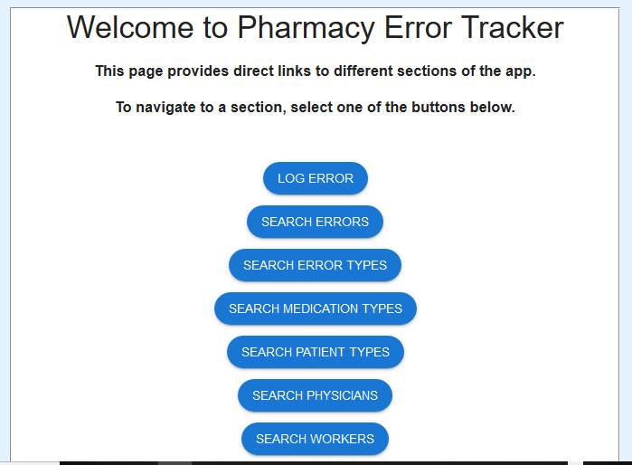

Figure 2: Welcome page for Administrator

\

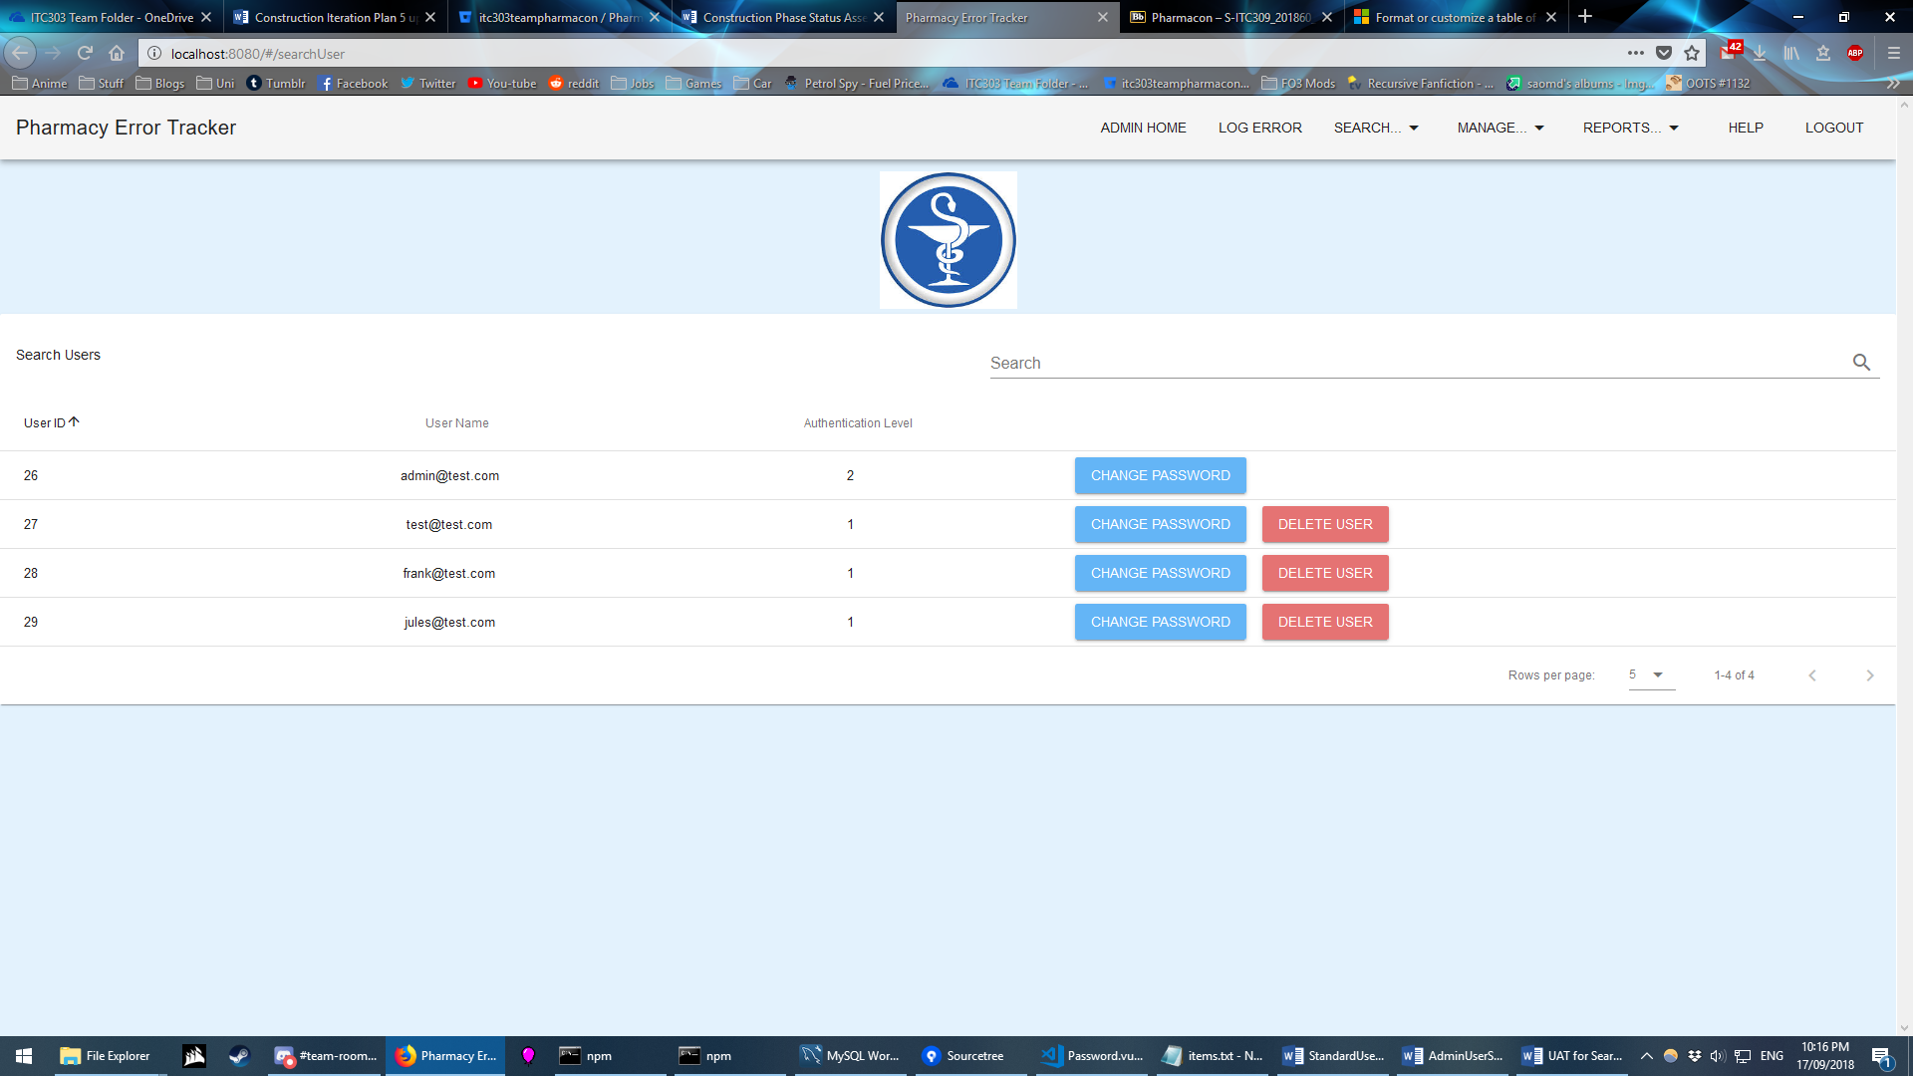

Figure 3: Using Search Tab – list of User records presented



Figure 4: Delete user frank@test.com selected

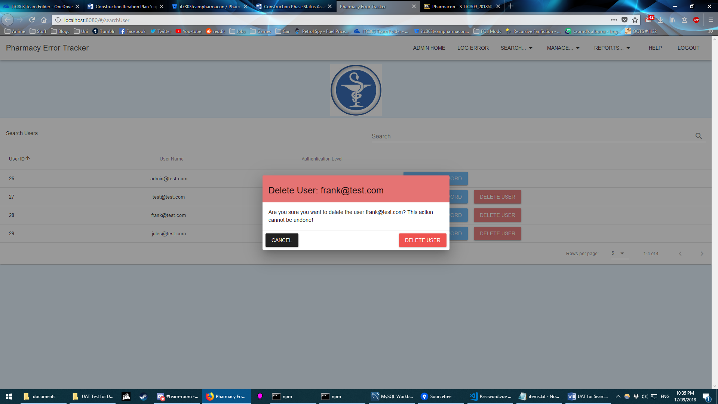

Figure 5: Confirmation pop-up shown

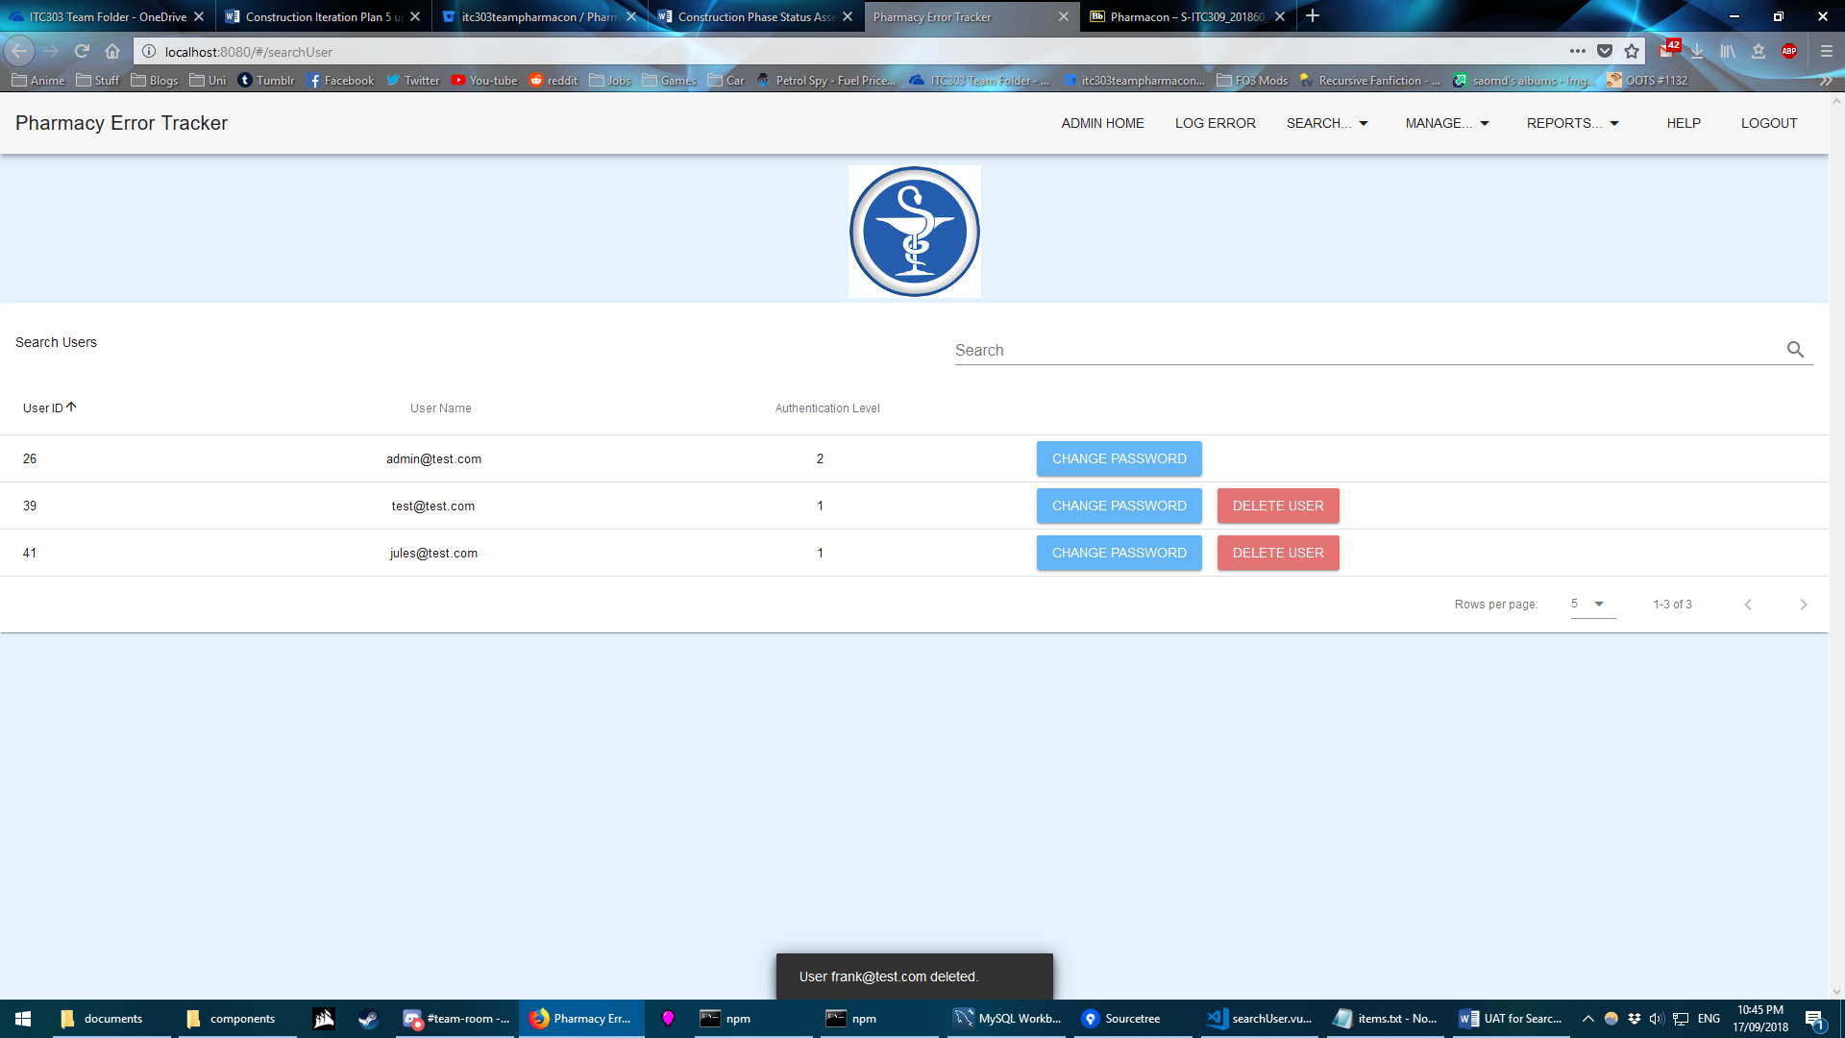

Figure 6: User successfully deleted.

EXPECTED ERROR MESSAGES:

None: The user is able to back out of deleting a user without causing an error path. The user is unable to delete their own account, and as only admins can delete accounts, there will always be at least one admin in the database at any time.